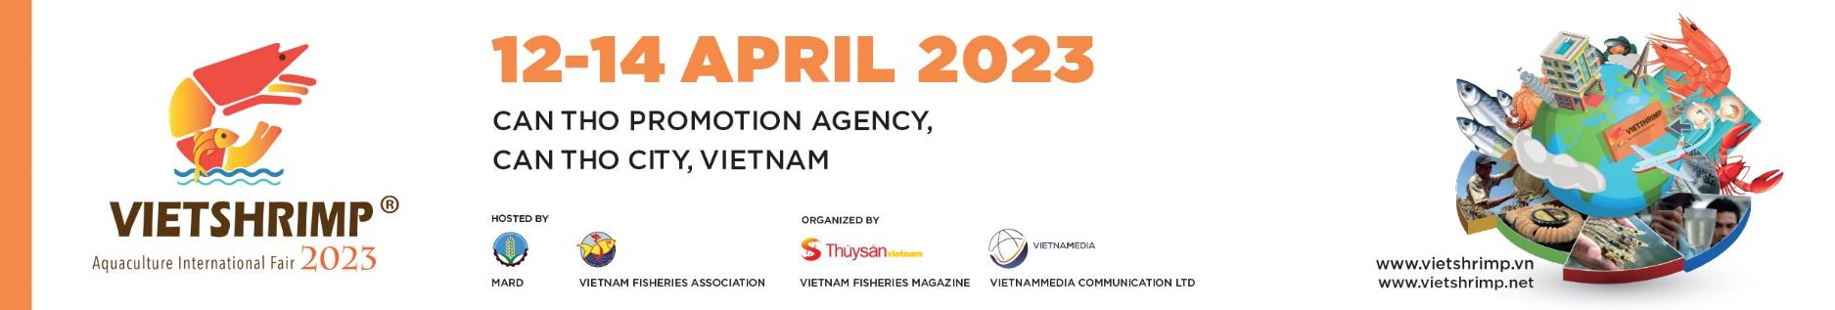

VietShrimp Aquaculture International Fair 2023
VietShrimp 2023 - “Innovative value chain upgrading”

PRESS RELEASE

Shrimp is one of the key export items that has been contributing significantly to the development of Vietnam's seafood industry and economy, and has created jobs for millions of people. Within a decade from 2010 to 2022, the proportion of shrimp export value had always been high, ranging from 36.8% to 50.4% of total seafood export turnover. In 2022, the total brackish water shrimp farming area in the country was 747,000 ha with the production output of more than 1 million tons, which was a 8.5% raise compared to 2021. With that, export turnover has risen 11.2% and reached 4.3 billion USD.
Vietnam’s shrimp industry has set the targets of 750,000 ha by 2023; total shrimp production by more than 1 million tons; export turnover by over 4.3 billion USD. By 2023, Vietnam's shrimp industry aims to reach 750,000 hectares with shrimp production output of all kinds exceeding 1 million tons, and export turnover exceeding 4.3 billion USD.
Over the years, Vietnam’s shrimp industry has shown consistent growth in farming area, output, and export value. However, due to limited production efficiency, this industry still faces the risk of unsustainable development, resulting in low income for shrimp farmers. Besides, there are also existing divisions of profits and responsibilities in the shrimp value chain. In addition, our country’s shrimp industry is facing challenges due to climate change, the environment, and diseases. International integration creates opportunities, but it also creates many challenges to compete, particularly when products not only must be of high quality and safety but also must be at competitive prices.
Mr. Nguyen Viet Thang, Chairman of the Vietnam Fisheries Society (VINAFIS) - Head of VietShrimp 2023 Organizing Committee, also emphasized this morning (April 12th, 2023) at the opening ceremony of the fourth VietShrimp Aquaculture International Fair 2023 (referred to as VietShrimp 2023): “Over the past years, Vietnam's shrimp industry has had many innovations and developments, especially in the rising of application of new technology in many households and businesses”. However, the production efficiency and competitiveness of Vietnamese shrimp products remain limited, and the industry continues to face numerous challenges. It is necessary to promote the value chain in order for Vietnamese shrimp to become more competitive in the market.
As a result, long-term development of the shrimp value chain is critical. To accomplish this, all stakeholders in the shrimp industry chain must work together to reduce production costs, improve quality, and increase the competitiveness of Vietnamese shrimp. VietShrimp 2023, with the theme “Innovative value chain upgrading”, was organized with the goal of becoming a “bridge” between all four professions: Managers, scientists, entrepreneurs, and farmers, all working toward the same goal. Action is being taken to achieve the goal of sustainable development for Vietnamese shrimp.
VietShrimp 2023 will be held from April 12 - 14th, 2023 at CanTho Promotion Agency (CPA) - 108A Le Loi, Cai Khe Ward, Ninh Kieu District, Can Tho City. With the approval of the Ministry of Agriculture and Rural Development, City People's Committee Can Tho, Vietnam Fisheries Society has joined forces with the General Department of Fisheries; Vietnam Aquaculture Magazine and other partners to organize this exhibition.
Previously, VietShrimp was held three times with huge success in 2016, 2018, and 2020, marking an important milestone for the Vietnamese shrimp industry by introducing a Specialized shrimp fair with the stature of Southeast Asia and Asia for the first time. Vietnam Aquaculture Magazine and VietnamMedia Co., Ltd. are the two units assigned by the Vietnam Fisheries Society to organize this event.
VietShrimp 2023 is one of the largest and most comprehensive Expos for the shrimp industry in Vietnam, Southeast Asia, and Asia in general. This year's Expo attracted more than 15,000 visitors, with 200 booths from 150 domestic and international businesses, and organizations operating in all fields related to the seafood industry in general and shrimp in particular, from seed, food, preparations, drugs, vaccines, processes, and technologies... Symposium sessions with many interested and knowledgeable managers, scientists, experts, and businesses participating and sharing useful information.
The Organizers of VietShrimp 2023 hope to continue receiving support in order to bring Vietnamese shrimp to many new lands, register and affirm the position and brand of Vietnamese shrimp on the global shrimp industry map. Thousands of shrimp farmers, farms, businesses, companies, domestic and international experts, departments, and visitors attended.

For further program details, please contact:
Ms. Hai Linh - Media Department
Email: hailinh@thuysanvietnam.com.vn
Mobile phone: +84 37.887.1423

About the organizer:
Vietnam Aquaculture Magazine
As Vietnam's leading fisheries magazine, Vietnam Aquaculture Magazine serves as a forum for farmers, fishermen, and businesses involved in aquaculture, exploitation, processing, consumption, and fisheries logistics services. Vietnam Aquaculture Magazine was founded under the Ministry of Information and Communications' Press Operation License No. 802/GP-BTTTT, with the purpose of propagating and disseminating the Party's guidelines, policies, and laws in all aspects of the Vietnam Fisheries Society and Vietnam fisheries industry's activities. Vietnam Aquaculture Magazine is a member of the Vietnam Fisheries Society.

VietnamMedia Communication Co., Ltd
VietnamMedia, founded in December 2014, is a consulting firm that provides modern, effective, and comprehensive communication solutions to customers in order to optimize their communication needs. VietnamMedia provides total communication solutions for all customers' propaganda and referral programs. Provide corporate event media services. VietnamMedia is asserting its position in the fields of media, online advertising, and e-commerce.

